1-Phoneme

🔊 What is a Phoneme?
# Source: AI Source: Provided by: [Data Path: Persons Table -> ID Column: 1, Name_En Column: Motasem Essam] -> From: [Chatgpt (GPT-4-turbo)] on [7/21/2025]
A phoneme is the smallest unit of sound in a language that can change the meaning of a word.

🧾 Definition:
# Source: AI Source: Provided by: [Data Path: Persons Table -> ID Column: 1, Name_En Column: Motasem Essam] -> From: [Chatgpt (GPT-4-turbo)] on [7/21/2025]
A phoneme is an abstract sound unit in a language. Changing one phoneme can result in a different word.

🧠 Key Points:
# Source: AI Source: Provided by: [Data Path: Persons Table -> ID Column: 1, Name_En Column: Motasem Essam] -> From: [Chatgpt (GPT-4-turbo)] on [7/21/2025]
- Phonemes are language-specific.
- They are not the actual sounds you hear (those are called phones) — they are the mental categories of sound.
- Written in slashes like this: /p/, /b/, /t/.

🧪 Examples in English:
# Source: AI Source: Provided by: [Data Path: Persons Table -> ID Column: 1, Name_En Column: Motasem Essam] -> From: [Chatgpt (GPT-4-turbo)] on [7/21/2025]
- Minimal Pair (shows different phonemes):
  - "bat" vs. "pat"
    - /b/ vs. /p/ → changing one sound changes the meaning
    - So, /b/ and /p/ are different phonemes
- "Tip" and "Trip"
  - Both have the phoneme /t/, but it might sound slightly different in each case — those are allophones of /t/, but the phoneme is the same.

📘 Phoneme vs. Allophone vs. Phone:
# Source: AI Source: Provided by: [Data Path: Persons Table -> ID Column: 1, Name_En Column: Motasem Essam] -> From: [Chatgpt (GPT-4-turbo)] on [7/21/2025]
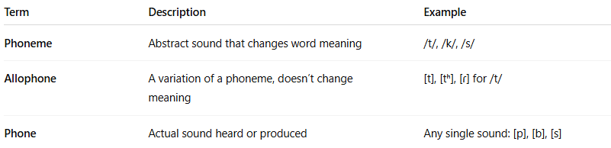
Term | Description | Example
Phoneme | Abstract sound that changes word meaning | /t/, /k/, /s/
Allophone | A variation of a phoneme, doesn’t change meaning | [t], [tʰ], [ɾ] for /t/
Phone | Actual sound heard or produced | Any single sound: [p], [b], [s]

how A variation of a phoneme, doesn’t change meaning
# Source: AI Source: Provided by: [Data Path: Persons Table -> ID Column: 1, Name_En Column: Motasem Essam] -> From: [Chatgpt (GPT-4-turbo)] on [7/21/2025]
A variation of a phoneme that doesn’t change meaning is called an allophone.

Key Idea:
# Source: AI Source: Provided by: [Data Path: Persons Table -> ID Column: 1, Name_En Column: Motasem Essam] -> From: [Chatgpt (GPT-4-turbo)] on [7/21/2025]
Allophones are different pronunciations or realizations of the same phoneme, and they do not change the meaning of the word.

Example in English:
# Source: AI Source: Provided by: [Data Path: Persons Table -> ID Column: 1, Name_En Column: Motasem Essam] -> From: [Chatgpt (GPT-4-turbo)] on [7/21/2025]
Let’s take the phoneme /t/:
- In “top” /tʰɑp/ – the /t/ is aspirated ([tʰ])
- In “stop” /stɑp/ – the /t/ is unaspirated ([t])
- In “butter” /ˈbʌtər/ – the /t/ is a flap in American English ([ɾ])
Even though these /t/ sounds are different, they are all allophones of the same phoneme /t/ because:
- They don’t change the meaning (they are still recognized as the word “top,” “stop,” or “butter”)
- Native speakers usually don’t notice the difference

Summary:
# Source: AI Source: Provided by: [Data Path: Persons Table -> ID Column: 1, Name_En Column: Motasem Essam] -> From: [Chatgpt (GPT-4-turbo)] on [7/21/2025]
- A phoneme is a sound unit that can change meaning (e.g., /p/ vs /b/: "pat" vs "bat")
- An allophone is a variation of a phoneme that does not change the word’s meaning
🗣️ Think of allophones as "accents" of the same sound — different flavors, same ingredient.

🎯 Quick Test: Is it a Phoneme?
# Source: AI Source: Provided by: [Data Path: Persons Table -> ID Column: 1, Name_En Column: Motasem Essam] -> From: [Chatgpt (GPT-4-turbo)] on [7/21/2025]
Ask:
- If I change this sound, does the word mean something else?
  - If yes → it's a different phoneme
  - If no → it's an allophone of the same phoneme

✅ Summary:
# Source: AI Source: Provided by: [Data Path: Persons Table -> ID Column: 1, Name_En Column: Motasem Essam] -> From: [Chatgpt (GPT-4-turbo)] on [7/21/2025]
A phoneme is the smallest unit of sound in a language that can distinguish meaning. It's an abstract sound category, made real through its different allophones.

2-Phone

🔊 What is a Phone (in Linguistics)?
# Source: AI Source: Provided by: [Data Path: Persons Table -> ID Column: 1, Name_En Column: Motasem Essam] -> From: [Chatgpt (GPT-4-turbo)] on [7/21/2025]
A phone is the smallest unit of sound in spoken language — a single, actual sound that can be produced and heard, regardless of its function or meaning in a particular language.

🧾 Definition:
# Source: AI Source: Provided by: [Data Path: Persons Table -> ID Column: 1, Name_En Column: Motasem Essam] -> From: [Chatgpt (GPT-4-turbo)] on [7/21/2025]
A phone is a concrete speech sound — one specific sound that a human mouth can produce and ears can hear.
It is different from a phoneme, which is a more abstract sound that functions to distinguish meaning in a language.

🧠 Key Characteristics of a Phone:
# Source: AI Source: Provided by: [Data Path: Persons Table -> ID Column: 1, Name_En Column: Motasem Essam] -> From: [Chatgpt (GPT-4-turbo)] on [7/21/2025]
- It’s a real sound, not just an idea.
- It can be recorded, measured, and transcribed using the International Phonetic Alphabet (IPA).
- It may or may not change meaning in a language.

🧪 Example:
# Source: AI Source: Provided by: [Data Path: Persons Table -> ID Column: 1, Name_En Column: Motasem Essam] -> From: [Chatgpt (GPT-4-turbo)] on [7/21/2025]
Let’s take the English word “little”:
- In some dialects, the “t” is pronounced as a quick flap, like a soft “d” sound.
- In IPA:
  - Standard [ˈlɪtəl]
  - With flap [ˈlɪɾəl] — here, [ɾ] is a phone
Even though [t] and [ɾ] are different phones, they don’t change the meaning of the word, so they are considered the same phoneme in English.

📘 Phone vs. Phoneme:
# Source: AI Source: Provided by: [Data Path: Persons Table -> ID Column: 1, Name_En Column: Motasem Essam] -> From: [Chatgpt (GPT-4-turbo)] on [7/21/2025]
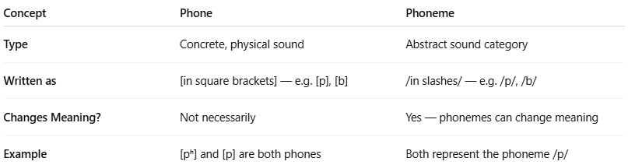
Concept | Phone | Phoneme
Type | Concrete, physical sound | Abstract sound category
Written as | [in square brackets] — e.g. [p], [b] | /in slashes/ — e.g. /p/, /b/
Changes Meaning? | Not necessarily | Yes — phonemes can change meaning
Example | [pʰ] and [p] are both phones | Both represent the phoneme /p/

✅ Summary:
# Source: AI Source: Provided by: [Data Path: Persons Table -> ID Column: 1, Name_En Column: Motasem Essam] -> From: [Chatgpt (GPT-4-turbo)] on [7/21/2025]
A phone is a specific speech sound, like [k], [s], or [ʃ]. It’s the physical sound that you make when you speak, regardless of whether it changes the meaning of a word.

3-Allophone

🗣️ What is an Allophone?
# Source: AI Source: Provided by: [Data Path: Persons Table -> ID Column: 1, Name_En Column: Motasem Essam] -> From: [Chatgpt (GPT-4-turbo)] on [7/21/2025]
An allophone is a variant of a phoneme — a different pronunciation of the same sound unit that does not change the meaning of a word in a particular language.

📘 Definition:
# Source: AI Source: Provided by: [Data Path: Persons Table -> ID Column: 1, Name_En Column: Motasem Essam] -> From: [Chatgpt (GPT-4-turbo)] on [7/21/2025]
An allophone is one of the possible spoken realizations (phones) of a single phoneme, used in different contexts but without changing word meaning.

🧠 Key Points:
# Source: AI Source: Provided by: [Data Path: Persons Table -> ID Column: 1, Name_En Column: Motasem Essam] -> From: [Chatgpt (GPT-4-turbo)] on [7/21/2025]
- Allophones are context-dependent: they appear in certain positions or environments (like before a vowel, at the start of a word, etc.).
- Speakers usually don’t notice them because they don’t affect word meaning.
- They're language-specific — what counts as an allophone in one language may be a separate phoneme in another.

🧪 Example: English /p/
# Source: AI Source: Provided by: [Data Path: Persons Table -> ID Column: 1, Name_En Column: Motasem Essam] -> From: [Chatgpt (GPT-4-turbo)] on [7/21/2025]
- In English, the phoneme /p/ has two common allophones:
  - [pʰ] — aspirated "p" (with a puff of air), like in "pin" → [pʰɪn]
  - [p] — unaspirated, like in "spin" → [spɪn]
✅ They are both allophones of the phoneme /p/
❌ Changing from one to the other does not change the meaning of the word.

🔁 Phone vs. Phoneme vs. Allophone:
# Source: AI Source: Provided by: [Data Path: Persons Table -> ID Column: 1, Name_En Column: Motasem Essam] -> From: [Chatgpt (GPT-4-turbo)] on [7/21/2025]
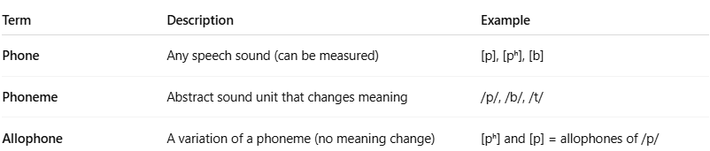
Term | Description | Example
Phone | Any speech sound (can be measured) | [p], [pʰ], [b]
Phoneme | Abstract sound unit that changes meaning | /p/, /b/, /t/
Allophone | A variation of a phoneme (no meaning change) | [pʰ] and [p] = allophones of /p/

💬 Another Example: /t/ in English
# Source: AI Source: Provided by: [Data Path: Persons Table -> ID Column: 1, Name_En Column: Motasem Essam] -> From: [Chatgpt (GPT-4-turbo)] on [7/21/2025]
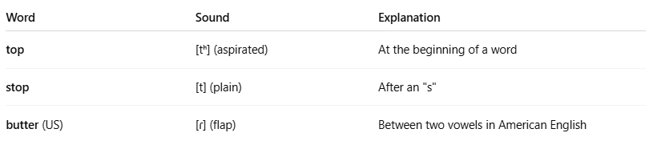
Word | Sound | Explanation
top | [tʰ] (aspirated) | At the beginning of a word
stop | [t] (plain) | After an "s"
butter (US) | [ɾ] (flap) | Between two vowels in American English
All three are allophones of /t/.

✅ Summary:
# Source: AI Source: Provided by: [Data Path: Persons Table -> ID Column: 1, Name_En Column: Motasem Essam] -> From: [Chatgpt (GPT-4-turbo)] on [7/21/2025]
An allophone is a variation of a phoneme that is pronounced differently depending on context but does not change word meaning.

4-IPA

🌐 What is the International Phonetic Alphabet (IPA)?
# Source: AI Source: Provided by: [Data Path: Persons Table -> ID Column: 1, Name_En Column: Motasem Essam] -> From: [Chatgpt (GPT-4-turbo)] on [7/21/2025]
The International Phonetic Alphabet (IPA) is a system of symbols used to represent every possible sound (or phone) that can be spoken in any human language — accurately and consistently.

📘 Definition:
# Source: AI Source: Provided by: [Data Path: Persons Table -> ID Column: 1, Name_En Column: Motasem Essam] -> From: [Chatgpt (GPT-4-turbo)] on [7/21/2025]
The IPA is a standardized alphabet of phonetic symbols used by linguists, language learners, speech therapists, and others to write down pronunciation of words exactly as they are spoken.

🔠 Why is IPA important?
# Source: AI Source: Provided by: [Data Path: Persons Table -> ID Column: 1, Name_En Column: Motasem Essam] -> From: [Chatgpt (GPT-4-turbo)] on [7/21/2025]
- The same spelling can be pronounced differently in different languages or dialects.
- IPA solves this by using one symbol for each distinct sound, no matter the language.

🧠 Examples: English words in IPA
# Source: AI Source: Provided by: [Data Path: Persons Table -> ID Column: 1, Name_En Column: Motasem Essam] -> From: [Chatgpt (GPT-4-turbo)] on [7/21/2025]
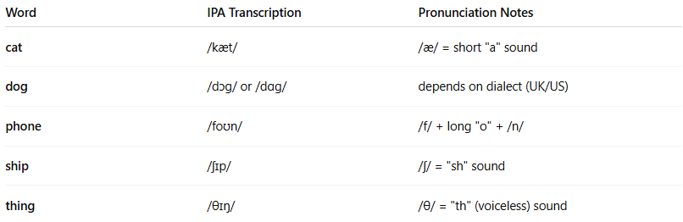

Word | IPA Transcription | Pronunciation Notes
cat | /kæt/ | /æ/ = short "a" sound
dog | /dɔg/ or /dɑg/ | depends on dialect (UK/US)
phone | /foʊn/ | /f/ + long "o" + /n/
ship | /ʃɪp/ | /ʃ/ = "sh" sound
thing | /θɪŋ/ | /θ/ = "th" (voiceless) sound

🧪 Key IPA Sounds and Symbols (Examples in English)
# Source: AI Source: Provided by: [Data Path: Persons Table -> ID Column: 1, Name_En Column: Motasem Essam] -> From: [Chatgpt (GPT-4-turbo)] on [7/21/2025]
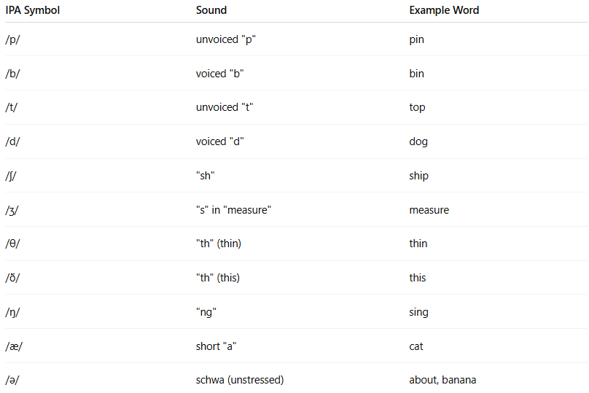

IPA Symbol | Sound | Example Word
/p/ | unvoiced "p" | pin
/b/ | voiced "b" | bin
/t/ | unvoiced "t" | top
/d/ | voiced "d" | dog
/ʃ/ | "sh" | ship
/ʒ/ | "s" in "measure" | measure
/θ/ | "th" (thin) | thin
/ð/ | "th" (this) | this
/ŋ/ | "ng" | sing
/æ/ | short "a" | cat
/ə/ | schwa (unstressed) | about, banana

🌍 Used For:
# Source: AI Source: Provided by: [Data Path: Persons Table -> ID Column: 1, Name_En Column: Motasem Essam] -> From: [Chatgpt (GPT-4-turbo)] on [7/21/2025]
- 🔤 Learning pronunciation
- 🗣️ Speech therapy
- 📚 Linguistic analysis
- 🎤 Language teaching
- 🎧 Dictionaries

✅ Summary:
# Source: AI Source: Provided by: [Data Path: Persons Table -> ID Column: 1, Name_En Column: Motasem Essam] -> From: [Chatgpt (GPT-4-turbo)] on [7/21/2025]
The International Phonetic Alphabet (IPA) is a universal system that uses special symbols to represent the exact sounds of spoken language — one sound = one symbol, across all languages.

